Computer Networks

HW #1 (30 Points)

Due date : 2014/4/11 Friday (Cyber Campus)

Things to Submit : studentid.c File (All code should be in one file.)

This homework is to implement a simple 2 person chatting application.

The following is an example of execution.

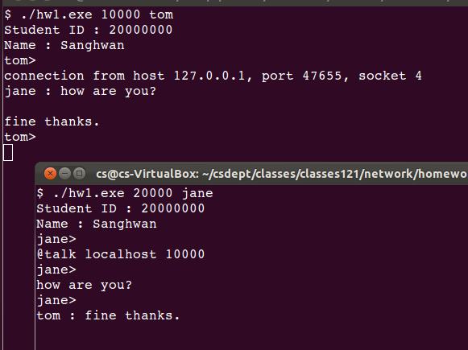

The application receives a tcp port numbers and an ID via the command line arguments.

When the user runs the application, he/she gives 2 arguments. The syntax is as follows.

$ hw1 tcpport userid

* tcpport : a TCP port number for accepting incoming connection
* userid : ID of the user running the application (a simple string)

In the above figure, the lower user (jane) initiates a connection to the upper user (tom) by the following command.

@talk hostname tcpport

* hostname : hostname of the target user
* tcpport : TCP port number of the target user for accepting the incoming connection

In the above example, the TCP port number of the upper user is 10000. So the lower user typed “@talk localhost 10000”.

When the connection is requested from the lower user, the upper user displays the information as follows.

connection from host 127.0.0.1, port 1741, socket 4

After the connection setup, when the lower user types some message, it is shown on the upper user’s screen. The upper user can also type some messages to the lower user. Basically, they can chat with each other. The typing sequence should not be fixed. For example, one user can type many lines and both users can type simultaneously.

Users may quit the chatting by using the following command.

@quit

When a user quits, the neighbors that have connections to the user can know that the connections are broken. Then the applications show the following message.

Connection Closed sd

* sd : the socket descriptor of the connection.

Furthermore, the quitted user or a new user should be able to connect the existing user without any problem. The following figure shows an example of such cases.

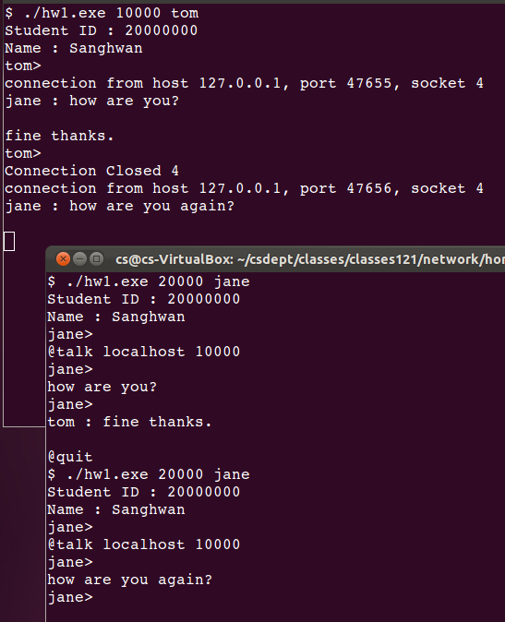

**Executable**

* An executable is attached so that you can test by yourself.
* It is compiled Ubuntu linux machine on VirtualBox environments.

**Template**

* We may want to use the attached template “hw1.c”.